Supermarket Sweep
Find these aisle categories and see if you can list at least three different items found in each one
Aisle category | Items found
Meat
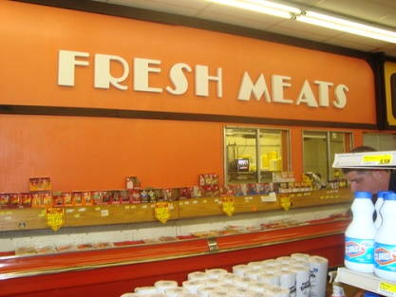

Seafood
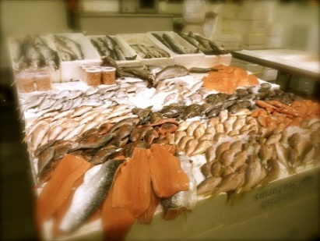

Health and Beauty
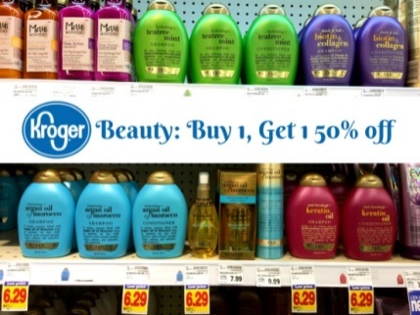

Frozen Foods
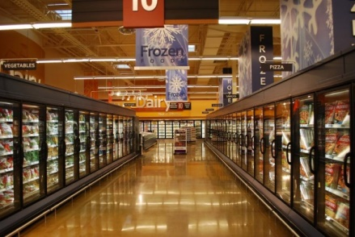

Bakery
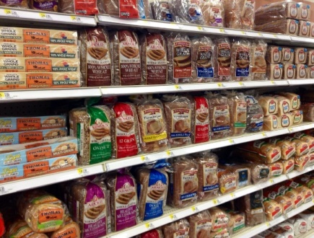

Fruit
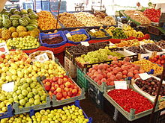

Vegetables
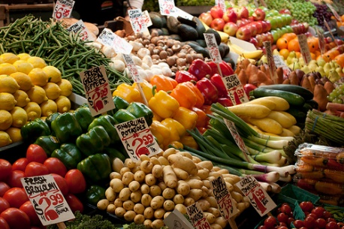

Baby Needs
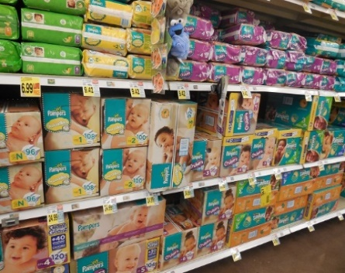

Category dice game
Print the dice nets on sturdy card, cut them out and make them up.
Roll both dice and name items from the category rolled that match the number rolled on the number dice e.g. 3 animals
