Describe the character

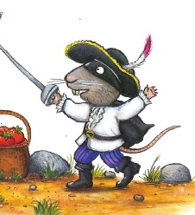

Tick the words that describe The Highway Rat
good |  | bad
big |  | little
yellow teeth |  | blue teeth
greedy |  | generous

